SECTION KF

LUBRICATING OIL COOLER

CONTENTS

|  |  |
| --- | --- |
|  | chapter |
| Removal and Dismantling .. | 1 |
| Cleaning, Re-tubing and Testing | 2 |
| Assembly and Fitting | 3 |
| Special Tools .. | 4 |

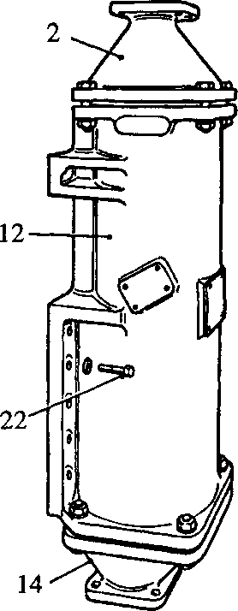

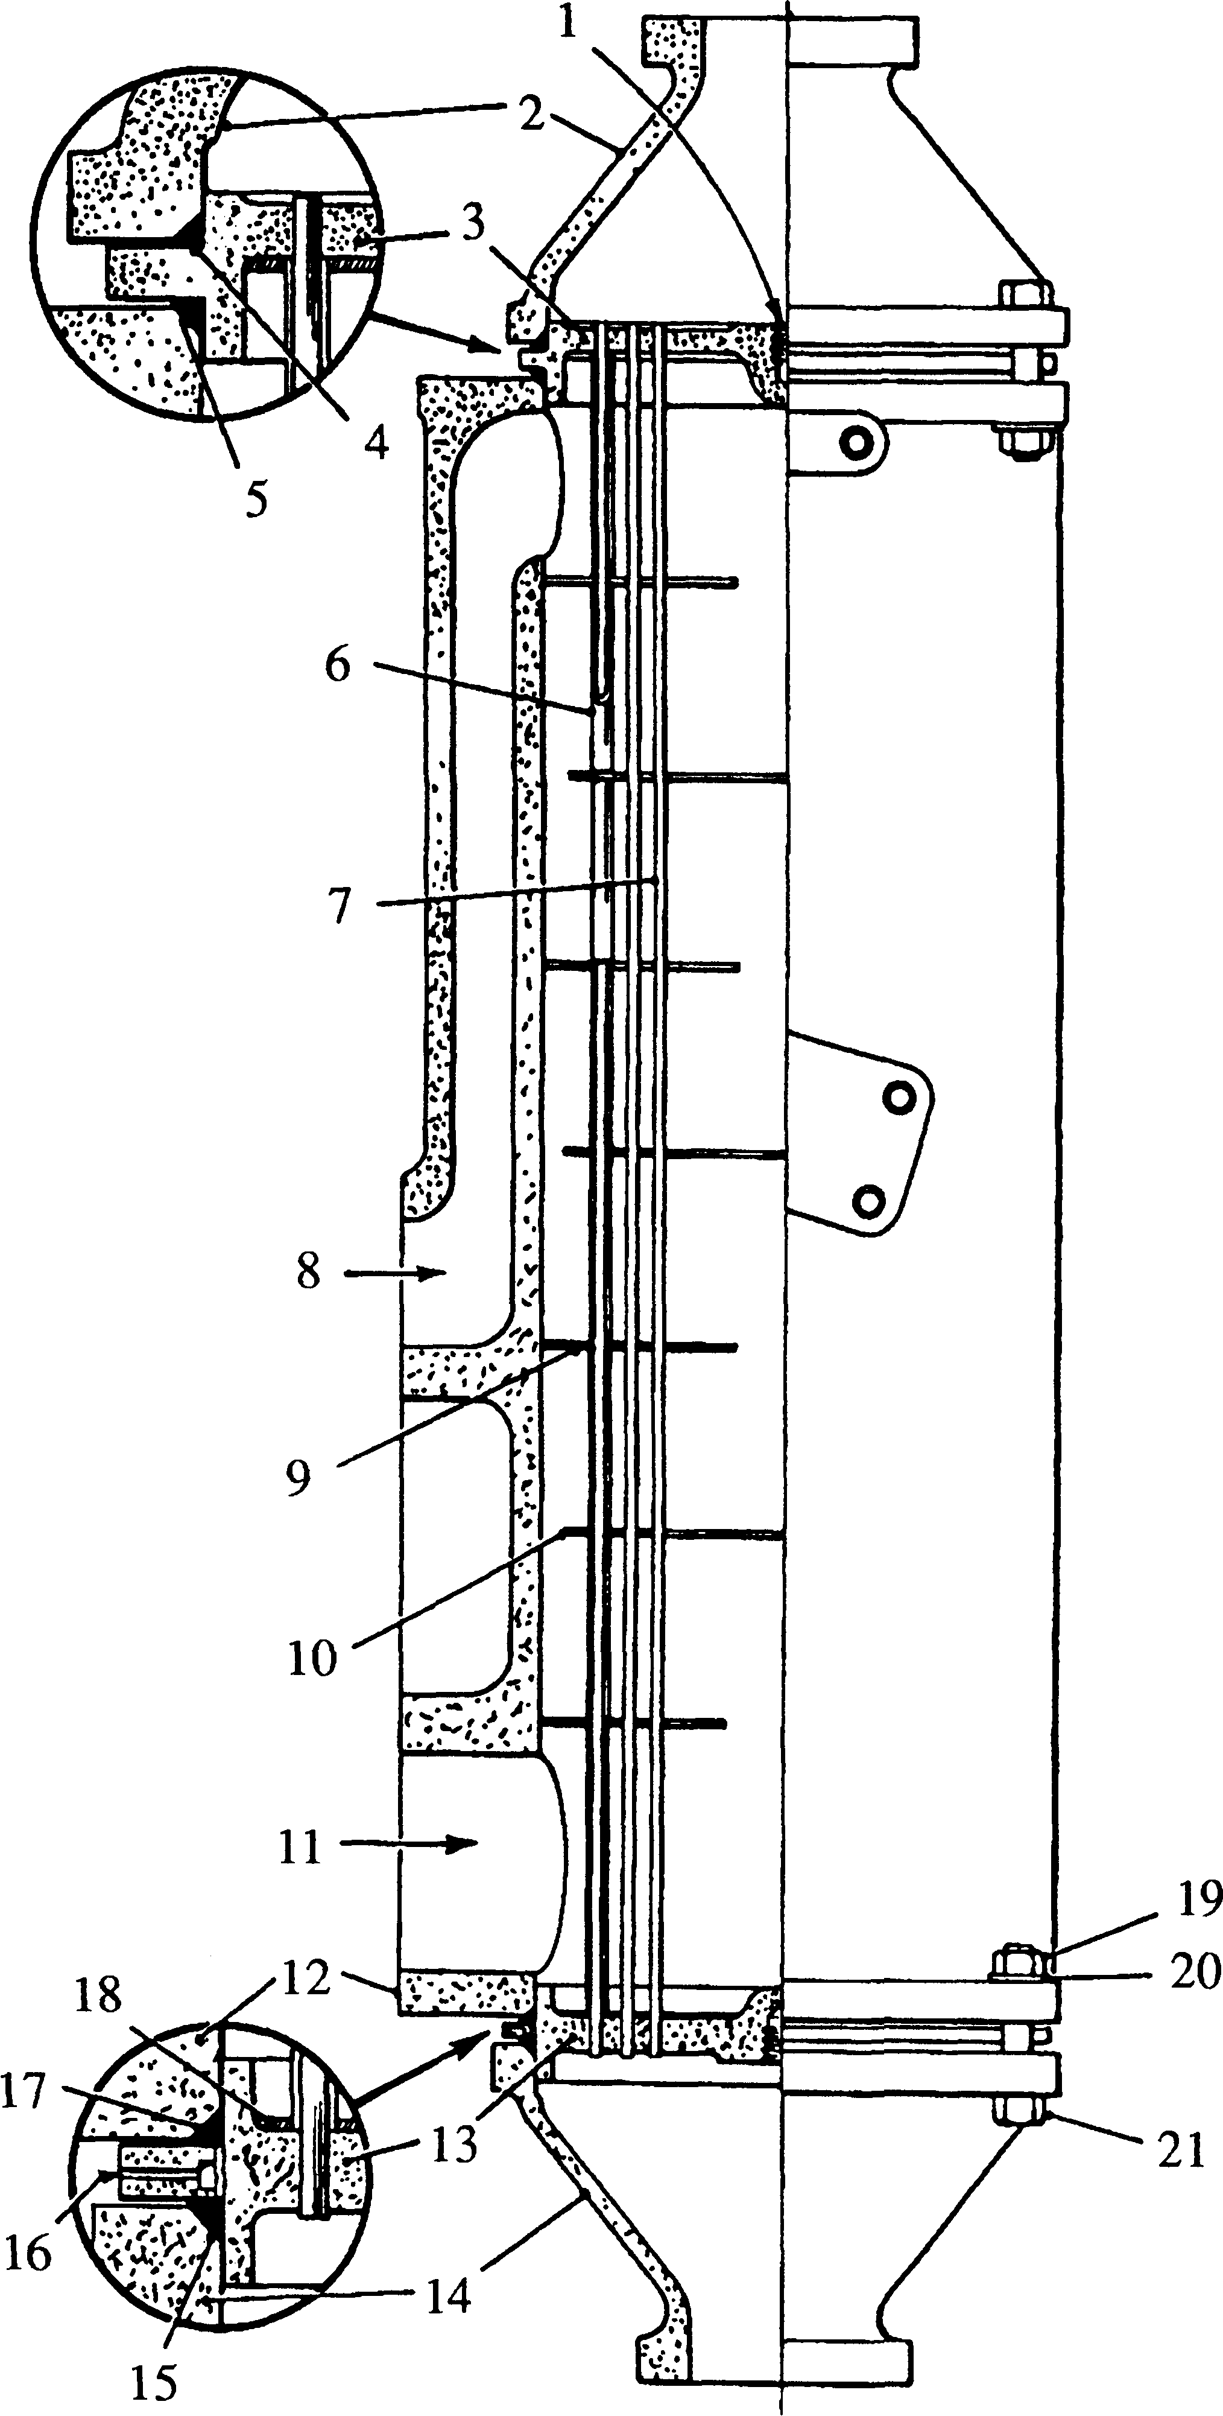

**Key To Numbers**

**SPD00362**

1. Tapping in fixed end tube plate
2. Fixed end water box (inlet)
3. Fixed end tube plate
4. Joint ring
5. Joint ring
6. Spacers
7. Water tubes
8. Oil outlet port
9. Large (ring) baffle
10. Small (disc) baffle
11. Oil inlet port
12. Cylinder
13. Expansion end tube plate
14. Expansion end water box (outlet)
15. Joint ring
16. Leakage ring
17. Joint ring
18. Solder bonding
19. Nut for item (21)
20. Dished washer
21. Bolt
22. Setbolt, cooler to free-end cover

Fig KF.l Lubricating Oil Cooler

REMOVAL AND DISMANTLING

Removal

1. Drain the sea water system. (Section KA).
2. Drain the fuel system. (Section GB).
3. Disconnect and remove all fuel supply piping between fuel filter, reservoir and fuel feed pump.
4. Remove fuel filter complete with drip tray.
5. Remove sea water pipe between charge air heater/cooler and lubricating oil cooler.
6. Release sea water discharge connection from oil cooler.
7. Secure a suitable sling to the lubricating oil cooler, remove setbolts (22)(Fig KF.l) securing the cooler to the engine free-end cover and lift the cooler away. Remove the 'O’ rings from the free-end cover recesses.

Dismantling

1. File register marks across the flanges of the water boxes, cylinder and fixed end tube plate.
2. Remove nuts (19)(Fig KF.l), bolts (21) and dished washers (20) and remove expansion end water box (14). Remove leakage ring (16) and joint rings (15) and (17).
3. Mount cooler vertically with fixed end water box (2) uppermost.
4. Remove securing nuts, bolts and dished washers, and remove fixed end water box (2). Remove joint ring (4).
5. Screw a suitable eye bolt into fixed end tube plate (3). The plate is tapped Ml6. A protective blanking plug may be fitted to the tapping.
6. Attach suitable lifting tackle and withdraw the tubestack from the cylinder. Remove joint ring (5).

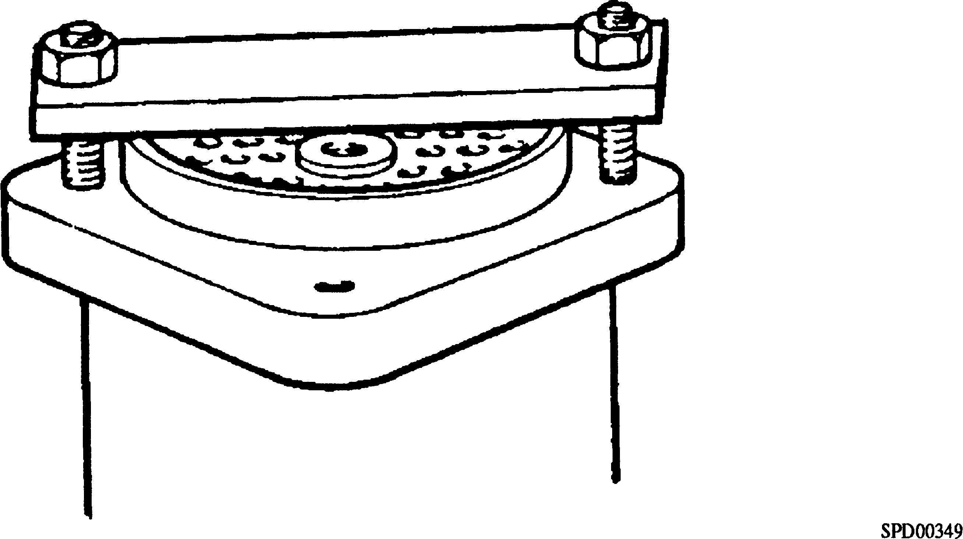

Fig KF.2 Method of 'starting' tubestack

NOTE The tubestack is a close fit in the cylinder and care must be taken to ensure a vertical lift to avoid damage to the tubestack during removal.

Owing to the close manufacturing tolerances, it may be difficult to remove the tubestack from a cooler that has been untouched for a number of years. On no account should levers be used under the fixed end tube plate to prise the stack loose. This will damage the plate and cause leakage when the cooler is reassembled. An effective method of 'starting' the stack is to place a suitable bar diametrically across the expansion end tubeplate and then pull the bar up to the cylinder by the progressive tightening of bolts which pass through the bar and holes in the cylinder flange (see Fig KF.2).

CLEANING, RE-TUBING AND TESTING

Cleaning

1. Degreasing of the lubricating oil side and descaling of the water side of the cooler should be carried out in accordance with normal workshop practice, bearing in mind the materials from which the oil cooler is constructed.

Cylinder

Water boxes

Tube plates

Tubes - V4 in x 26 swg

Baffles

Aluminium alloy Gunmetal

Nickel aluminium bronze 70/30 Cupro Nickel 70/30 Cupro Nickel

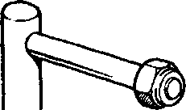image239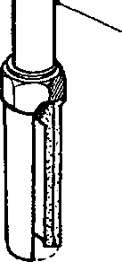image241

l

**3**

**4**

**5**

a

6

**9**

7

8

SPD00363

**Key To Numbers**

1. Centralising pin
2. Tube brush
3. Tube support rod - 4 in
4. Tube support rod - 5 in
5. Tube support rod - 6 in

|  |  |  |
| --- | --- | --- |
|  | 6. | Roller expander |
|  | 7. | Tube drill |
| long | 8. | Brush rod |
| long  long | 9. | Tube extractor |

Fig. KF3 Oil cooler cleaning and repair kit

Repairs and Overhaul

1. Whenever possible it is recommended that major overhaul of the lubricating oil cooler is carried out by Serck Heat Transfer. All repairs can be supported by a technical report on the condition of the lubricating oil cooler, and advice given to prevent any recurrence of any avoidable troubles.
2. Normally lubricating oil coolers are repaired by tubestack replacement.
3. Where it is impractical for the cooler to be returned to the manufacturer for repair, and no new tubestack is available, tubes may be renewed with the aid of the toolkit shown in Fig KF.3. The method used for tube renewal is the same as that used for the heat exchanger.

CAUTION TUBE RENEWAL SHOULD ONLY BE CARRIED OUT WHERE FULL WORKSHOP FACILITIES ARE AVAILABLE, TOGETHER WITH A MEANS OF PRESSURE TESTING.

Testing

1. With the cooler assembled, apply pressure to the cooler on both sides of the tubes independently, and examine the tubes, plates and joints for leakage.
2. The test pressures are as follows:

Oil side (over tubes) 150 lb/in2 (10.55 kg/cm2)

Coolant side (through tubes) 70 lb/in2 ( 4.92 kg/cm2)

ASSEMBLY AND FITTING

Assembly

NOTE All joints and 'O' rings must be fitted dry.

1. Mount cylinder (12)(Fig KF.l) vertically with the oil ports at the lower end.
2. Screw a suitable eye bolt (Ml6) into fixed end tube plate (3), attach lifting tackle and lift tubestack.
3. Pass joint ring (5) over the tubestack and locate against the inner face of the fixed tube plate. If required, the joint ring may be retained in position with petroleum jelly.
4. Lower the tubestack into the cylinder, taking care to avoid damage to the large baffle plates (9), and align the register marks on the fixed tube plate and cylinder.
5. Remove lifting tackle and eyebolt.
6. Place joint ring (4) over the tube plate spigot, place fixed end box (2) in position, aligning the register marks, and secure with bolts (21) and nuts (19). Dished washers (20) should be fitted beneath the nuts. Tighten the nuts evenly to avoid distortion of the box.
7. Invert the cooler or lay in horizontal position.
8. Place joint ring (17), leakage ring (16) and joint ring (15) over the expansion end tubeplate (13), place expansion end box (14) in position aligning the register marks and secure with bolts (21), nuts (19) and dished washers (20). Tighten the nuts evenly to avoid distortion of the box.
9. Refit any plugs that have been removed using new joints.

NOTE Brass plugs must not befitted to the coolant side of the cooler.

Fitting

1. Fit new 'O' rings to oilway recesses in the free-end cover facing (Section FH). Retain the rings in position, if necessary, with petroleum jelly.
2. Fit a suitable sling to the oil cooler, lift into position and secure with setbolts (22) and dished washers.
3. Fit and secure the sea water discharge connection to the lower end of the oil cooler.
4. Fit sea water pipe between charge air heater/cooler and oil cooler.
5. Fit fuel filter complete with drip tray to the oil cooler facings.
6. Fill and vent the fuel system.

CHAPTER 4

SPECIAL TOOLS

The following special tools are sufficient for carrying out all general maintenance, dismantling, overhaul and assembly operations on the lubricating oil cooler as detailed in this section.

NOTE These tools are only shown in the Illustrated Parts List if they have been ordered as part of the contract.

|  |  |  |
| --- | --- | --- |
| DESCRIPTION | PART NO | USE |
| Tool kit | OD23649P20 | For cleaning tubestack and renewing tubes |

**SECTION KF**

**HEAT EXCHANGER**

CONTENTS

|  |  |
| --- | --- |
|  | Chapter |
| General | 1 |
| Removal and Dismantling .. | 2 |
| Cleaning | 3 |
| Testing and Tube Renewal .. | 4 |
| Assembly and Fitting | 5 |
| Acid Descalents for Water Circuit .. | 6 |
| Special Tools .. | 7 |

CHAPTER 1

GENERAL

1. The heat exchanger (Fig. KF4) is arranged for coolant/sea water heat transfer.
2. The engine coolant flows through cylinder (14) passing over tubes (3), the flow being directed by alternate disc and ring baffle plates (12) and (13). The coolant inlet and outlet ports form part of the cylinder. The use of coolant in a closed circuit results in little or no fouling or scale deposit, therefore no provision is made for inspection of this side of the heat exchanger other than by tube stack removal.
3. The sea water flows through tubes (3) of the tubestack, entering and leaving via ports in the fixed end water box (18). To enable examination of the sea water side to be carried out in situ without disturbing the piping, expansion end cover (10) may be easily removed for inspection of the tubestack.
4. The heat exchanger is mounted, on feet (15) forming part of the cylinder casting, and secured with Ml6 setbolts.
5. To restrict attack to the sea water system by acids and pollution in certain sea water areas, sacrificial protector rods (1) are fitted. These rods require checking regularly during the first weeks of operation to establish the rate at which they are eroding and a pattern of wear noted, for regular maintenance and replacement according to local requirement.

REMOVAL AND DISMANTLING

NOTE Although inspection of the sea water side of the heat exchanger may be carried out in situ, it is recommended that the cooler be removed and dismantled before carrying out servicing operations.

Removal

1. Drain the engine cooling system (Section KA). In addition to the engine drain points, drain points are provided on the underside of the cylinder assembly through 1/2 in BSP x 1/2 in NFPT adaptors (16) to which lockable drain cocks are fitted.
2. Isolate and drain the sea water system. Drain plug (9) is provided on the expansion end cover (10).
3. Release the coolant and sea water piping at the heat exchanger flanges and remove joints. Remove local sections of piping, if necessary, to allow removal of heat exchanger.
4. Fit a suitable sling and lifting tackle to the heat exchanger, release Ml6 securing setbolts and lift heat exchanger off its mountings.

Dismantling

1. Release M20 securing nuts (8) and withdraw expansion end cover (10), remove leakage ring (4) together with joint rings (11).
2. Mount heat exchanger vertically with fixed end water box (18) uppermost.
3. Release securing nuts (19) and remove fixed end water box (18) and joint ring (2).
4. Unscrew plug (20) from fixed tubeplate (17) and screw in a suitable eye bolt. The plate is tapped M20 x 2.5.
5. Attach suitable lifting tackle and withdraw the tubestack from the cylinder. Remove remaining joint ring (2).

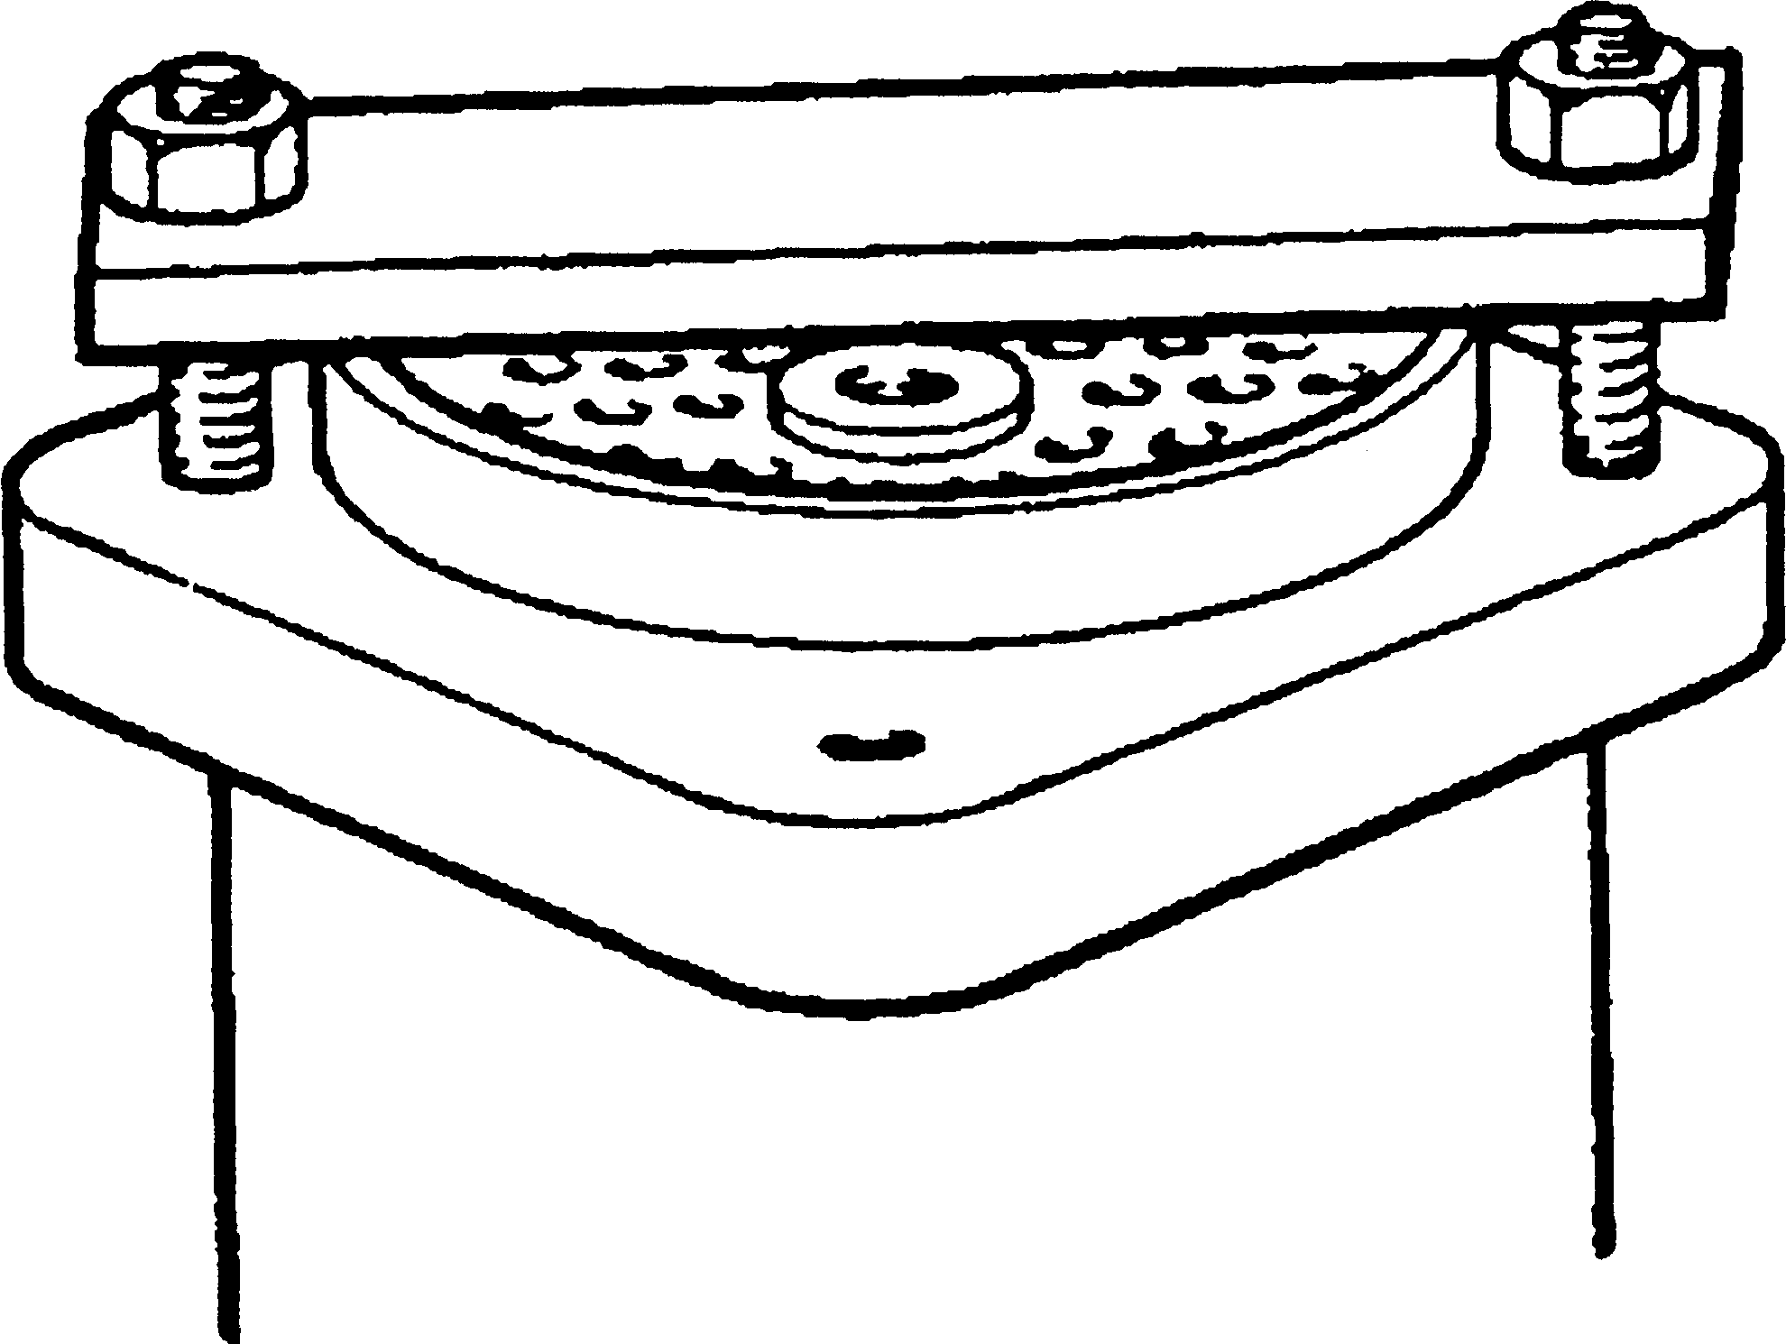

SPD00349

Fig. KF1 - Method of 'starting' tubestack

NOTE The tubestack is a close fit in the cylinder and care must be taken to ensure a vertical lift to avoid damage to the tubestack during removal.

Owing to the close manufacturing tolerances, it may be difficult to remove the tubestack from a heat exchanger that has been untouched for a number of years. On no account should levers be used under the fixed end tube- plate to prise the stack loose. This will damage the plate and cause leakage when the cooler is reassembled. An effective method of starting the stack is to place a suitable bar across the expansion end tubeplate and water box studs and then pull the bar up to the cylinder by progressively tightening the securing nuts (see Fig KF.l).

CHAPTER 3

CLEANING

1. Cleaning can be carried out either by mechanical or by chemical treatment methods, but in some circumstances both methods may have to be employed.
2. When chemical methods of cleaning are used great care should be taken to ensure that the chemicals do not have any adverse effect on the materials of the heat exchanger. When a chemical cleaning compound is purchased, the supplier should be given full details of the materials of construction and the nature of the deposit. This is particularly important when aluminium alloys are used. Many products are suitable for cleaning aluminium alloys, but those which are strongly alkaline or acidic can cause excessive attack and should not be used.
3. All of the descaling cleaners are strong acids and are extremely dangerous to both personnel and their clothing. In use, they may produce considerable frothing due to the evolution of gases. It is therefore essential that these acid cleaners are used strictly in accordance with the manufacturers instructions. The amount of acid required will vary according to the quantity of scale to be removed. Ensure that sufficient acid has been added to remove all of the deposit.

WARNING ALWAYS ADD ACID TO WATER, NEVER VICE VERSA

1. The proprietary brands listed at the end of this section have been tested by Serck Heat Transfer, and found to be satisfactory for cleaning and with no detrimental effect on the standard cooler materials.
2. Where mechanical methods of cleaning are employed, great care should be taken to ensure that the tubes are not mechanically damaged.
3. Before commencing cleaning operations make sure that a new set of correct joints are available together with the necessary toolkit.

COOLANT SIDE

1. Little if any scaling or fouling will occur on this side of the heat exchanger due to the use of coolant. Any fouling or scaling should be dealt with by chemical treatment as mechanical cleaning is impracticable on the outer surfaces of the tubes. Chemical treatment is as for the sea water side.

SEA WATER SIDE

Mechanical Cleaning

1. The sea water surfaces of the heat exchanger are often found to be covered with a powdery and loosely adherent deposit caused by the deposition of small particles of silt and rust or by heavy deposits of algae slime. Such deposits are best removed by brushing through the tubes with the special brushes supplied in the tool kit.
2. In action, rotate the brush and rod in a clockwise direction to avoid unscrewing the brush head from the rod assembly. If possible attach the rod assembly to an electric hand drill which will speed up the cleaning and prevent unscrewing. The use of a water hose will help to keep the brush clean and will carry away the loosened deposits.

LIMITED RIGHTS LEGEND

6

USE, DUPLICATION OR DISCLOSURE OF THIS INFORMATION WHICH IS THE PROPERTY

OF GEC ALSTHOM DIESELS LIMITED BY THE U.S. GOVERNMENT OR BOLLINGER IS SUBJECT TO THE RESTRICTIONS SET FORTH IN DOD FAR SUPP 252.227-7013 (a) 15.

Key To Numbers

|  |  |  |  |
| --- | --- | --- | --- |
| 1. | Tube drill | 8. | Tube brush |
| 2. | Wrench | 9. | Connector |
| 3. | Centralising pin | 10. | Tube plug |
| 4. | Taper drift | 11. | Brush rod plug |
| 5. | Roller expander | 12. | Square extension |
| 6. | Extension rod | 13. | Tubular extension |
| 7. | Brush handle |  |  |

Fig KF.2 Cooler cleaning and re-tubing tools

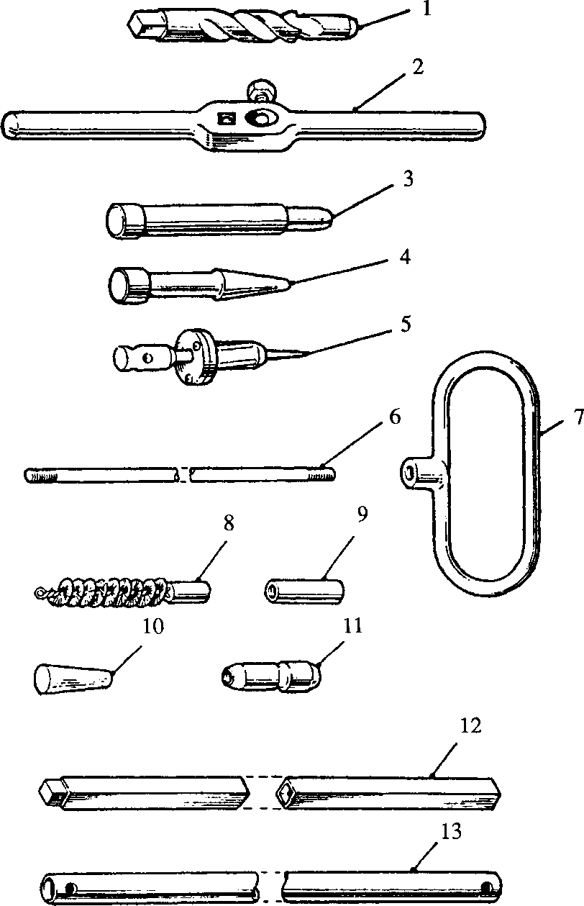The importance of removing these soft deposits and obstructions regularly cannot be over emphasised, since there is a danger of corrosion from partially obstructed tubes together with increased pressure losses and a drop in performance.

3.10

3.11

**SPD00351**

Careful brushing is essential, since if the tubes are mechanically damaged they may suffer rapid failure from corrosion mechanisms. Where tubes are obstructed by solid foreign bodies, do not force the brush through the tubes as this may damage the tube walls.

1. If the deposits are hard and do not respond to brushing, then cleaning by chemical treatment must be carried out.

Chemical Cleaning

1. In some cases coolant surfaces may be found to be coated with a heavy scale which is often known as 'Hard Water Scale'. Those scales may be formed from calcium carbonate, calcium sulphate or silicates. These scales are best removed by acid descaling
2. The various chemical descaling processes outlined will remove scales consisting mainly of calcium carbonate with ease. Scales composed largely of calcium sulphate or silicates may not respond to chemical cleaning but the descalent may have a loosening effect which may assist subsequent mechanical cleaning.
3. The silicate scales seldom respond to either chemical or mechanical cleaning and when the scale thickness seriously affects cooler performance the only remedy is to fit a new tubestack.
4. Acid descaling should be carried out by immersion of the tubestack in a separate tank. If the deposit is found to be oily then descaling can be assisted by prior degreasing. All the listed cleaners have been tested by Serck Heat Transfer, and are suitable for use with standard cooler materials at the concentrations and temperatures recommended by the manufacturers.
5. Proprietary products contain a corrosion restrainer which reduces attack on bare metal surfaces. Only acids containing restrainers should be used when cleaning in situ. If the tubestack is removed from the cylinder however, it can be cleaned by immersing in a dilute hydrochloric acid solution which does not contain a restrainer.
6. After acid descaling, the unit should be thoroughly rinsed with water and the tubes brushed through. The unit should then be re-washed with water, followed by rinsing with a 5% washing soda solution to neutralise any remaining acid.

TESTING AND TUBE RENEWAL

1. Whenever possible it is recommended that major overhaul of the heat exchanger is carried out by Serck Heat Transfer. All repairs can be supported by a technical report on the condition of the heat exchanger, and advice given to prevent any recurrence of any avoidable troubles.
2. Where it is impractical for the heat exchanger to be returned to the manufacturer for repair, and no new tubestack is available, tubes may be renewed with the aid of the toolkit shown in Fig KF.2. It must be emphasised that tube renewal should only be carried out where full workshop facilities are available, together with a means of pressure testing.
3. Where such facilities are not available, the complete tubestack should be renewed.
4. As a temporary measure a defective tube(s) should be isolated by using the wooden plugs supplied with each tool kit. A plug should be driven securely into ends of the tube(s). New tubes or a new tubestack should be fitted as soon as possible.

Testing

1. With the heat exchanger assembled, apply pressure on both sides of the tubes independently and examine the tubes, plates and joints for leakage.
2. The test pressures are as follows:-

Coolant side (over tubes) 7.03 kg/cm2 (100 lb/in2)

Sea water side (through tubes) 7.03 kg/cm2 (100 lb/in2)

Tube Renewal

1. The baffle plates are a close fit to the outer diameter of the tubes in the stack. To avoid distortion and damage to the plates during tube removal, the tubestack should be descaled and all deposits removed before attempting to remove the tubes.
2. Remove tubestack from heat exchanger cylinder and mount the tubestack in a horizontal position. Mount so as to avoid damage to the tubes and baffle plate.
3. Fig KF.3/I - Fit tube drill (l)(Fig KF.2) to wrench (2), fill drill flutes with grease to retain cuttings and drill out defective tube end in expansion end tube plate until free of solder bonding on inner face of tubeplate. Remove drill and clean away burrs from end of tube.
4. Fig KF.3/2 - Insert centralising pin (3)(Fig KF.2) through the tubeplate and locate the pilot portion of the pin in the tube bore.
5. Fig KF.3/3 - Using tube drill (l)(Fig KF.2) and wrench (2), drill out defective tube end in fixed tubeplate. Withdraw drill, remove burrs from end of tube and replace drill locating the pilot portion of the drill in the tube bore.
6. Fig KF.3/4 - Drive the centralising pin into the expansion end tubeplate until the head contacts plate, forcing the tube, guided by tube drill (l)(Fig KF.2), through the fixed end tubeplate. Keep a close watch on the gill plates when 'starting' the tube to ensure that distortion is not taking place due to tube plate adhesion.

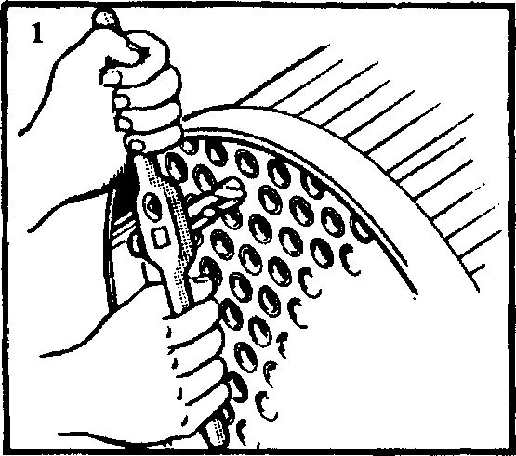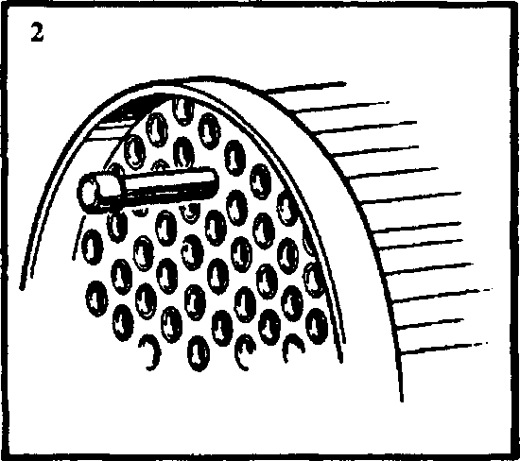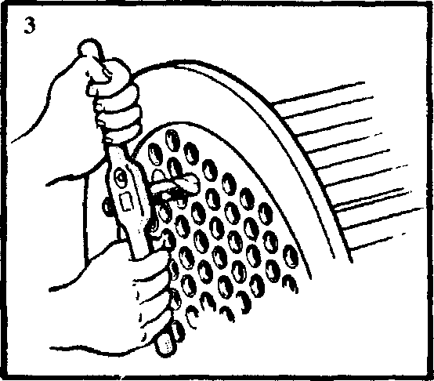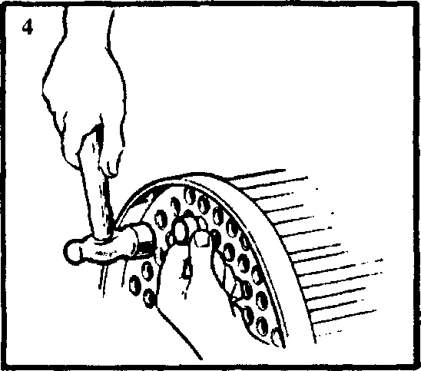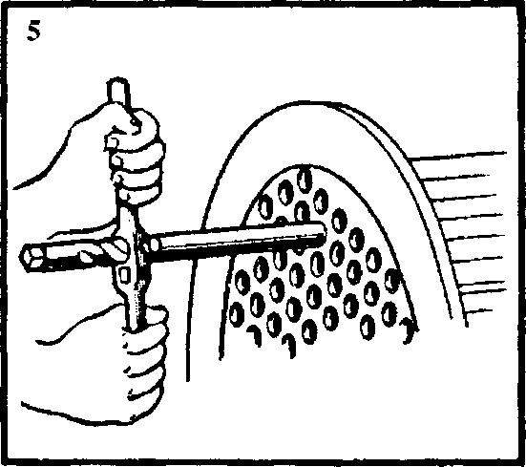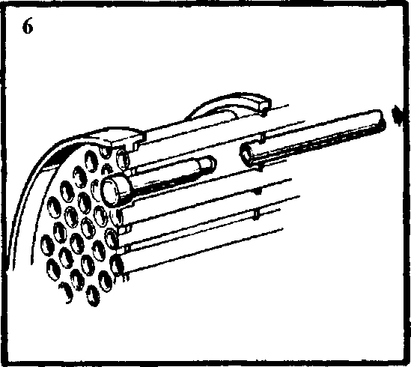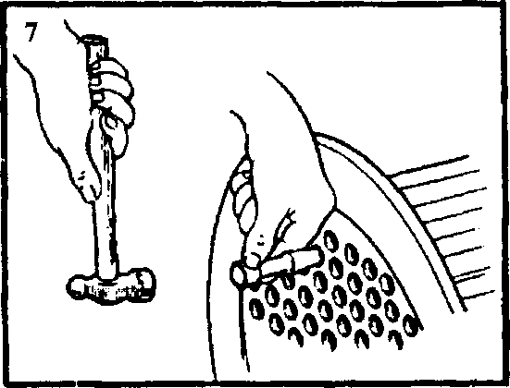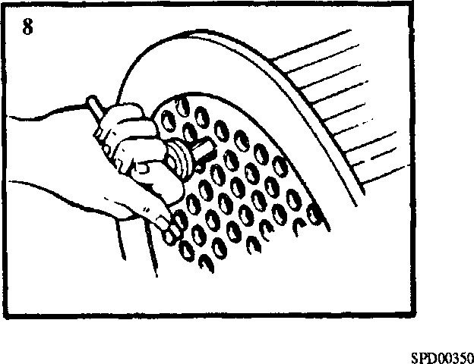

Fig KF.3 Method of re-tubing

1. Fig KF.3/5 - Place wrench (2)(Fig KF.2) over the tube end and lock the wrench and

tube to the pilot portion of the drill with the wrench grubscrew.

1. Fig KF.3/6 - Carefully work the tube out of the stack by means of the wrench.

Remove the centralising pin from the expansion end tubeplate.

1. Fig KF.3/7 - Carefully clean out the tubeplate holes. Do not overwork thereby enlargening the holes. Clean the ends of the new tube to allow for solder bonding after fitting. Insert the new tube, taking care not to damage the gill plates and secure in position by expanding with taper drift (4) at each end.
2. Fig KF.3/8 - Insert roller expander (5)(Fig KF.2) into the tube and rotate in a clockwise direction using light finger pressure. Allow the expander to feed itself into its full extent, do not force the feed. Repeat for the other end of the tube.
3. Mount the tubestack vertically and apply a small quantity of flux to the outer diameter of the tube as close as possible to the inner face of the tubeplate. Working from the outer face of the tubeplate, heat the tube sufficiently to 'run' the solder on the tubeplate inner face to complete the seal between tube and tubeplate. Localise the heating as much as possible. Repeat for the other end of the tube.

ASSEMBLY AND FITTING

Assembly (Fig KF.4)

NOTE All joints and 'O' rings must be fitted dry.

1. Mount cylinder assembly (14) vertically.
2. Screw an eye bolt into the tapped hole in fixed end tubeplate (17) attach lifting tackle and lift tubestack (3).
3. Pass a new joint ring (2) over the tubestack and locate against the inner face of the fixed end tubeplate flange. If required the joint ring may be retained in position with petroleum jelly.
4. Lower the tubestack into the cylinder taking care to avoid damage to the stack and align the register marks on the fixed tubeplate and cylinder.
5. Remove lifting tackle and eyebolt and screw in and tighten tubeplate blanking plug
6. . Centre punch threads to lock plug in position.
7. Place a new joint ring (2) over the tubeplate spigot, fit the fixed end water box (18) over the four studs and fit and secure the nuts (19). Tighten nuts evenly to avoid distortion.
8. Invert the heat exchanger or lay in a horizontal position to allow access to the expansion end.
9. Place new joint ring (11), leakage ring (4) and second new joint ring (11) over the expansion end tubeplate, pass expansion end cover (10) over its retaining studs and secure with four nuts (8). Tighten nuts evenly to avoid distortion.
10. Fit adaptors (16), drain cocks, vent plugs (6), new protector rods (1) with plugs
11. , and drain plugs (9), all with new fibre washers (5) and (22) to required position.

Fitting

1. Using a suitable sling, lift heat exchanger into position and fit and tighten M16 securing setbolts.
2. Using new joints, connect coolant and sea water piping.
3. Fill engine cooling system. The system is self venting (see Section DA).
4. The sea water pump is driven from the engine crankshaft and it will therefore be necessary to run the engine to fill the sea water system. The air vent plug (6) on the heat exchanger end cover should be opened to help vent the unit. Refer also to the Shipbuilders Instructions for venting.

ACID DESCALENTS FOR WATER CIRCUITS

|  |  |  |
| --- | --- | --- |
| TYPE OF DEGREASANT | BRAND | SUITABILITY FOR ALUMINIUM ALLOYS |
| LIQUID | H.T.L.3A (Houseman & Thompson Ltd) | Not recommended |
|  | Pensalt PM-90 (Pensalt Metal Processing) | Not recommended |
|  | Clensol ’P’ and Clensol ’LP' (Clensol Ltd) | Not recommended |
|  | Cleanix H.C. (Clensol Ltd) | Recommended |
|  | Armohib 28 inhibitor and Dilute  Hydrochloric Acid Sol (Armour Hess Chemicals Ltd) | Not recommended |
|  | Uninhibited Hydrochloric Acid (Dilute Solution) | Not recommended |
| SOLID | H.T.L. NO. 5 (Houseman & Thompson Ltd) | Not recommended |
|  | Cleanix Powder (Clensol Ltd) | Recommended |

The above products have been tested by Serck Heat Transfer and have been found to be suitable for descaling, whilst at the same time having no significant effect on the materials of construction, when used in accordance with the manufacturers instructions. No attempt has been made to compare the suitability, efficiency and cost of similar competitive products.

CHAPTER 7

SPECIAL TOOLS

The following special tools are sufficient for carrying out all general maintenance, dismantling, overhaul and assembly operations on the heat exchanger as detailed in this section.

NOTE These tools are only shown in the Illustrated Parts List if they have been ordered as part of the contract.

|  |  |  |
| --- | --- | --- |
| DESCRIPTION | PART NO | USE |
| Toolkit | OD28961 | For removal and fitting of tubes |

Key To Numbers

|  |  |
| --- | --- |
| 1. | Protector rod |
| 2. | Joint ring |
| 3. | Tubestack |
| 4. | Leakage ring |
| 5. | Washer for plug |
| 6. | Vent plug |
| 7. | Stud |
| 8. | Nut |
| 9. | Drain plug |
| 10. | Cover expansion end |
| 11. | Joint ring |
| 12. | Disc baffle plate |
| 13. | Ring baffle plate |
| 14. | Cylinder assembly |
| 15. | Mounting foot holes |
| 16. | Adaptor |
| 17. | Fixed end tubeplate |
| 18. | Fixed end water box |
| 19. | Nut |
| 20. | Blanking plug |
| 21. | Protector rod plug |
| 22. | Washer for plug |

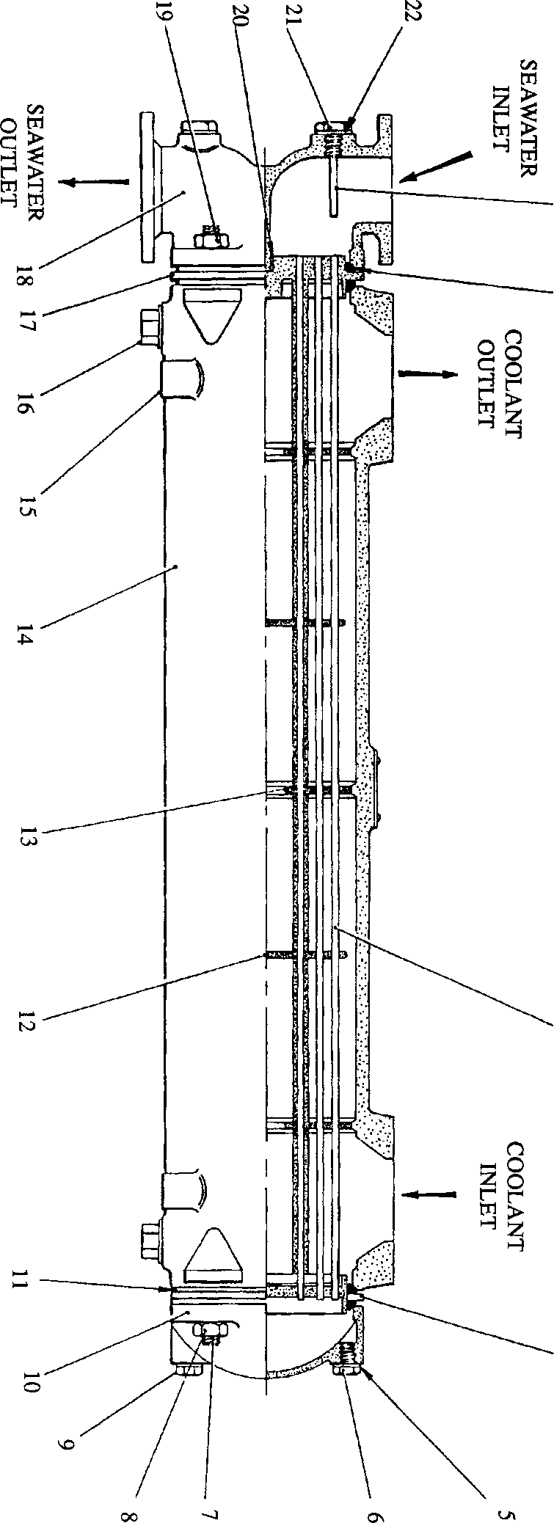

**SPD00354**

Fig KF.l Heat exchanger

SECTION KF

FUEL OIL COOLER

CONTENTS

chapter

General .. .. .. .. .. .. .. .. .. 1

Removal, Dismantling and Inspection .. .. .. .. .. 2

Assembly and Fitting .. .. .. .. .. .. .. 3

CHAPTER 1

GENERAL

1. The fuel system is of the full flow type incorporating a cooler to reduce the temperature of the fuel after passing through the fuel injection pump and before it is returned to the supply tank.
2. The fuel oil cooler is mounted in two metal straps and secured to the charge air heater/cooler outlet casing at the free-end of the engine.
3. The cooling medium is sea water which is piped from the main sea water cooling system before the heat exchanger and returned to the main system after the heat exchanger for discharge overboard.

1 2 3 4 5 678

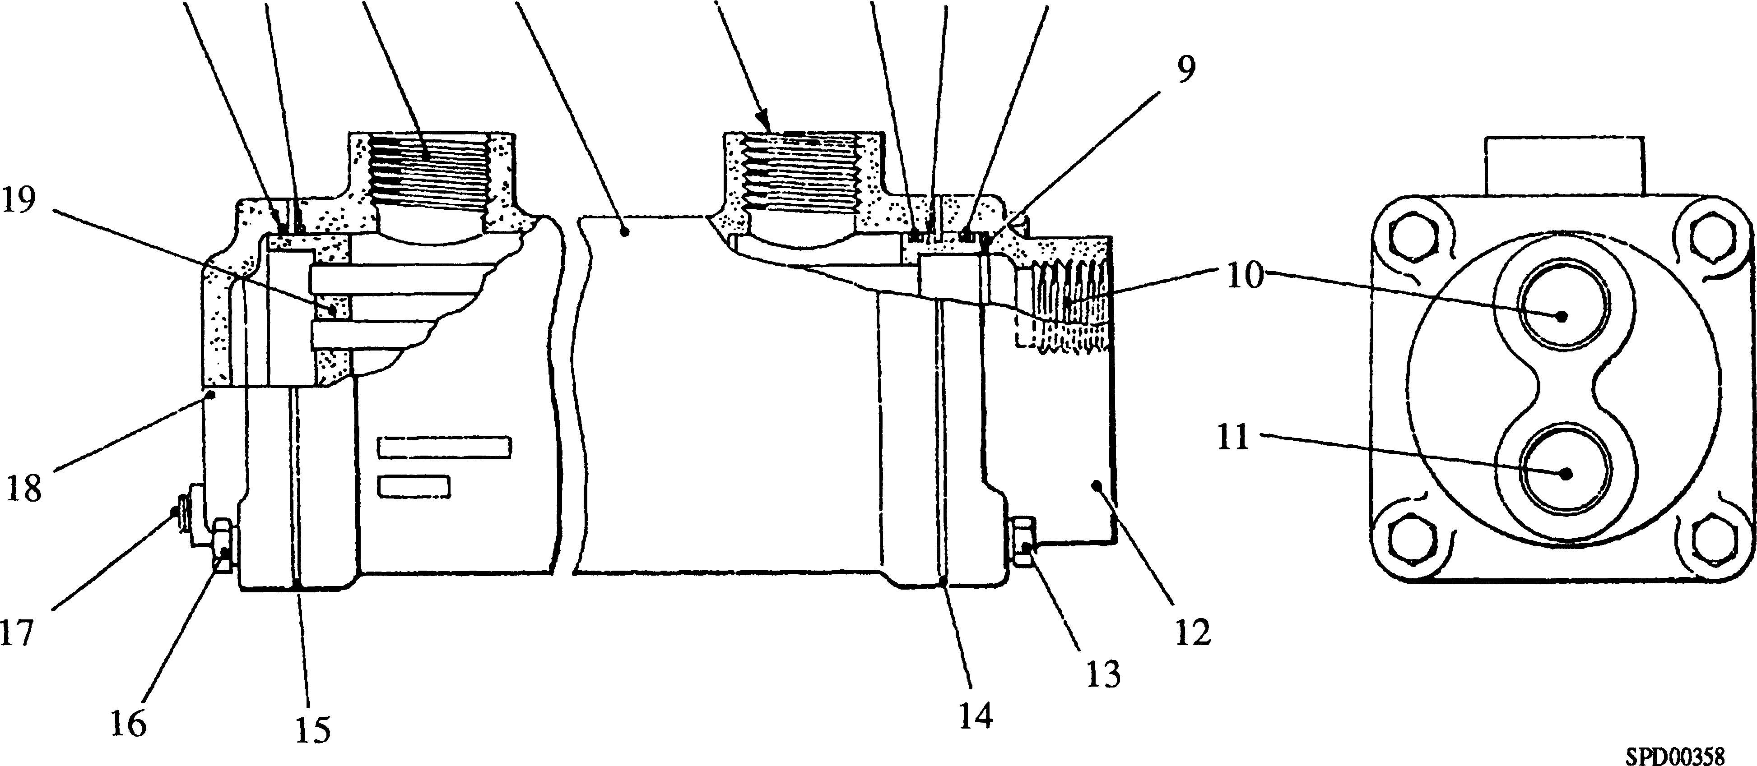

|  |  |  |  |
| --- | --- | --- | --- |
| Key To Numbers  1. 'O' ring | | 11. | Sea water inlet |
| 2. | 'O' ring | 12. | Fixed end box |
| 3. | Fuel oil inlet | 13. | Setscrew |
| 4. | Body | 14. | Retaining plate |
| 5. | Fuel oil outlet | 15. | Spacing washer |
| 6. | 'O' ring | 16. | Setscrew |
| 7. | Adaptor plate | 17. | Sea water drain |
| 8. | 'O' ring | 18. | Expansion end cover |
| 9. | Rib seal | 19. | Tubestack assembly |
| 10. | Sea water outlet |  |  |

Fig KF.l Fuel Oil Cooler

CHAPTER 2

REMOVAL, DISMANTLING AND INSPECTION

Removal

1. Isolate the fuel supply.

NOTE It is not necessary to drain the complete fuel system.

1. Isolate the sea water cooling system, remove drain plug (17) and drain the sea water from the cooler.
2. Remove sea water inlet and outlet pipes.

NOTE There is no facility for draining the fuel oil and it will be necessary to rotate the cooler through 90° after slackening the securing straps to drain the fuel.

1. Disconnect and remove the fuel oil inlet and outlet pipes.
2. Supporting the weight of the oil cooler, remove the four setscrews and spring washers securing fuel oil cooler strap brackets and remove the top straps. Lift away the cooler and remove the remaining straps.

Dismantling

1. Remove setscrews (13) and and spring washers and remove fixed end box (12), retaining plates (14) and rib seal (9). Discard the seal.
2. Remove setscrews (16) and spring washers and remove expansion end cover (18) and spacing washers (15)
3. Withdraw tubestack (19) from body (4) and remove and discard 'O' rings (1), (2), (6) and (8)

Inspection and Cleaning

1. Cleaning can be carried out by mechanical and chemical treatment and usually both methods will be required.
2. Great care must be taken to ensure that the chemicals used do not have an adverse effect on the materials of the oil cooler. These are:-
3. The majority of deposits found in the sea water side can be removed by the use of a suitable tube brush.
4. Remove all traces of old jointing materials. Check all mating surfaces for superficial damage likely to impair sealing. Examine threaded components for serviceability.
5. Visually inspect the condition of the bores of the tubes. Pressure test each side of the tubestack independently to 6.9 bar (100 lbf/in2) and replace any suspect tubes in accordance with current workshop practice.

|  |  |
| --- | --- |
| COMPONENT | MATERIAL |
| Cylinder  Water box and End cover  Tubes  Tubeplates  Baffles | Aluminium Alloy  Gun metal  70/30 Cupro Nickel  Nickel Aluminium Bronze  Brass |

CHAPTER 3

ASSEMBLY AND FITTING

NOTE All joints and 'O' rings must befitted dry.

Assembly (Fig KF.l)

1. Locate new 'O' rings (6) and (8) into grooves in tubestack adaptor plate (7), and insert tubestack into body (4).
2. Fit a new rib seal (9) into fixed end box (12). Fit the fixed end box, position retaining plates (14) and secure with setscrews (13) and spring washers.
3. Fit 'O' ring (2) position spacing washers (15) and fit 'O' ring (1) and expansion end cover (18) and secure with setscrews (16) and spring washers.
4. Fit drain plug (17).
5. Pressure test both sides of the cooler independently for leaks to 4 bar (60 lbf/in2).

Fitting

1. Support the fuel oil cooler and using the strap brackets, secure it to the charge air heater/cooler free-end cover using setscrews, spring and plain washers.
2. Connect the fuel oil inlet and outlet pipes.
3. Connect the sea water inlet and outlet pipes to the oil cooler.
4. De-isolate, prime and vent the fuel system.
5. De-isolate, prime and vent the sea water cooling system.

**SECTION KF**

**HEAT EXCHANGER**

CONTENTS

|  |  |
| --- | --- |
|  | Chapter |
| General | 1 |
| Removal and Dismantling .. | 2 |
| Cleaning | 3 |
| Testing and Tube Renewal .. | 4 |
| Assembly and Fitting | 5 |
| Acid Descalents for Water Circuit .. | 6 |
| Special Tools .. | 7 |

CHAPTER 1

GENERAL

1. The heat exchanger (Fig. KF4) is arranged for coolant/sea water heat transfer.
2. The engine coolant flows through cylinder (14) passing over tubes (3), the flow being directed by alternate disc and ring baffle plates (12) and (13). The coolant inlet and outlet ports form part of the cylinder. The use of coolant in a closed circuit results in little or no fouling or scale deposit, therefore no provision is made for inspection of this side of the heat exchanger other than by tube stack removal.
3. The sea water flows through tubes (3) of the tubestack, entering and leaving via ports in the fixed end water box (18). To enable examination of the sea water side to be carried out in situ without disturbing the piping, expansion end cover (10) may be easily removed for inspection of the tubestack.
4. The heat exchanger is mounted, on feet (15) forming part of the cylinder casting, and secured with M16 setbolts.
5. To restrict attack to the sea water system by acids and pollution in certain sea water areas, sacrificial protector rods (1) are fitted. These rods require checking regularly during the first weeks of operation to establish the rate at which they are eroding and a pattern of wear noted, for regular maintenance and replacement according to local requirement.

CHAPTER 2

REMOVAL AND DISMANTLING

NOTE Although inspection of the sea water side of the heat exchanger may be carried out in situ, it is recommended that the cooler be removed and dismantled before carrying out servicing operations.

Removal

1. Drain the engine cooling system (Section KA). In addition to the engine drain points, drain points are provided on the underside of the cylinder assembly through V2 in BSP x V2 in NFPT adaptors (16) to which lockable drain cocks are fitted.
2. Isolate and drain the sea water system. Drain plug (9) is provided on the expansion end cover (10).
3. Release the coolant and sea water piping at the heat exchanger flanges and remove joints. Remove local sections of piping, if necessary, to allow removal of heat exchanger.
4. Fit a suitable sling and lifting tackle to the heat exchanger, release M16 securing setbolts and lift heat exchanger off its mountings.

Dismantling

1. Release M20 securing nuts (8) and withdraw expansion end cover (10), remove leakage ring (4) together with joint rings (11).
2. Mount heat exchanger vertically with fixed end water box (18) uppermost.
3. Release securing nuts (19) and remove fixed end water box (18) and joint ring (2).
4. Unscrew plug (20) from fixed tubeplate (17) and screw in a suitable eye bolt. The plate is tapped M20 x 2.5.
5. Attach suitable lifting tackle and withdraw the tubestack from the cylinder. Remove remaining joint ring (2).

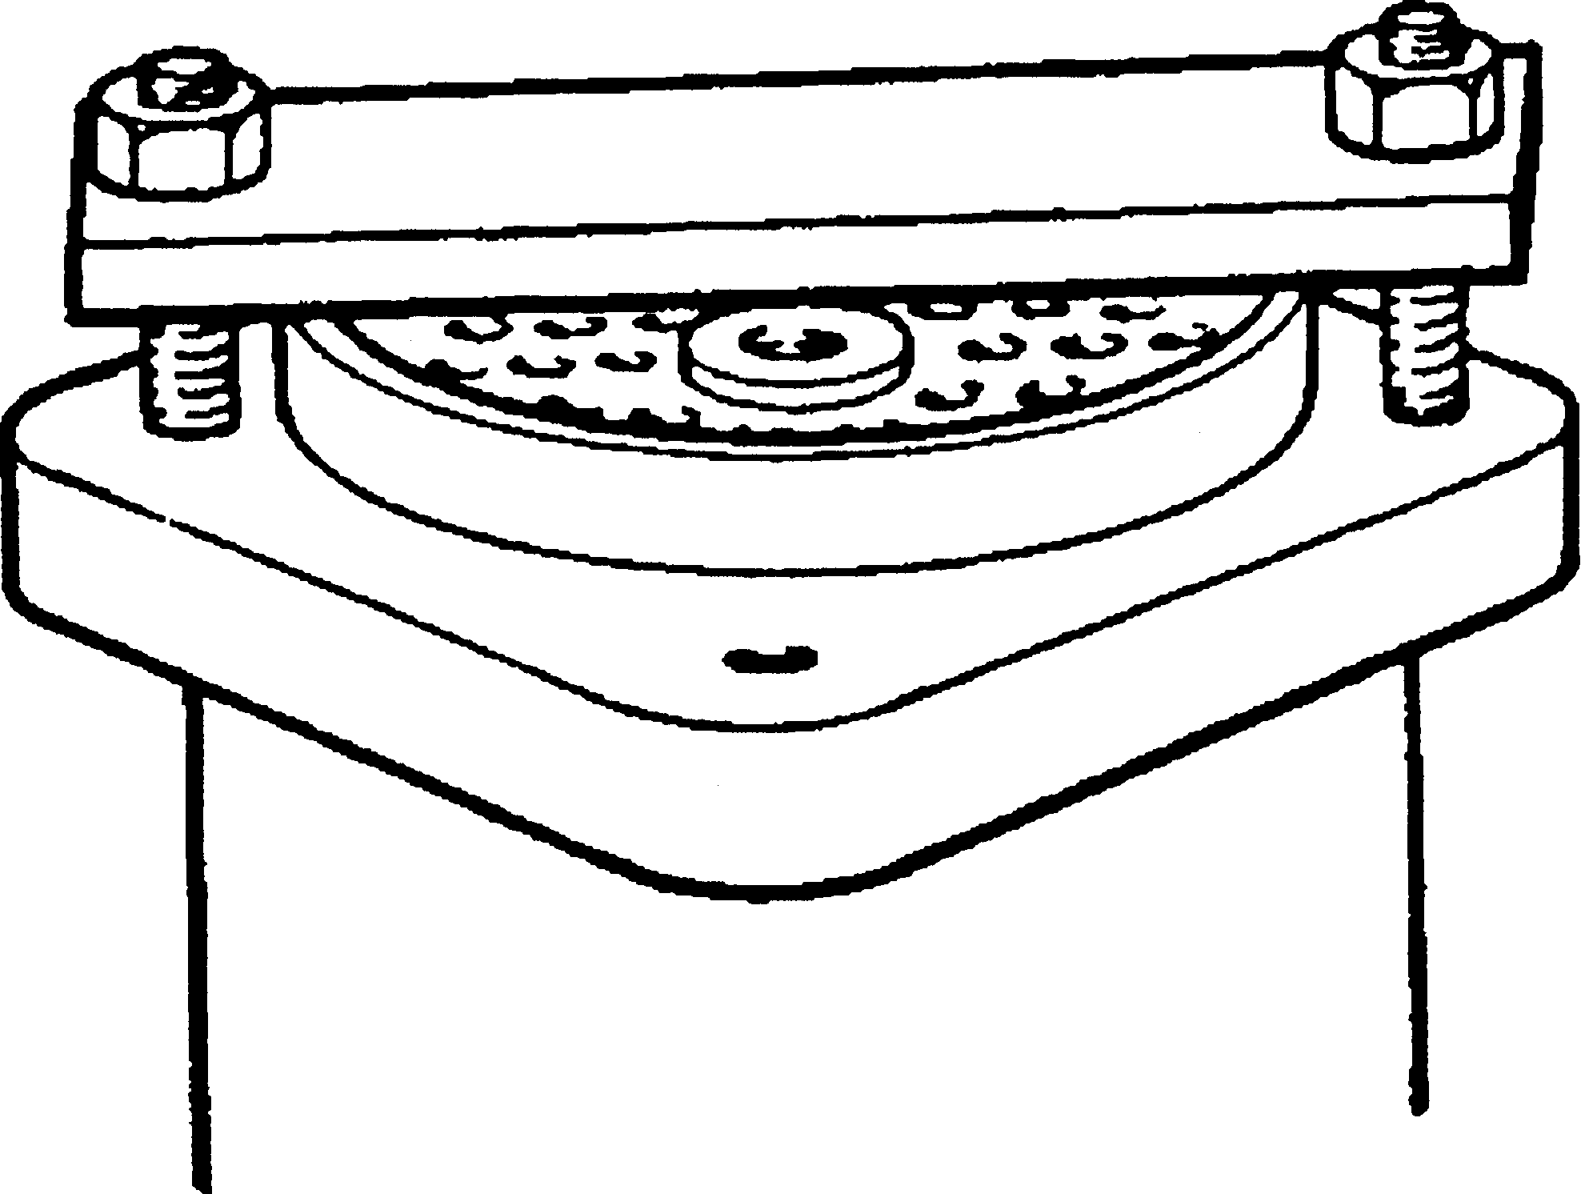

SPD00349

Fig. KF1 - Method of 'starting' tubestack

NOTE The tubestack is a close fit in the cylinder and care must be taken to ensure a vertical lift to avoid damage to the tubestack during removal.

1. Owing to the close manufacturing tolerances, it may be difficult to remove the tubestack from a heat exchanger that has been untouched for a number of years. On no account should levers be used under the fixed end tube- plate to prise the stack loose. This will damage the plate and cause leakage when the cooler is reassembled. An effective method of starting the stack is to place a suitable bar across the expansion end tubeplate and water box studs and then pull the bar up to the cylinder by progressively tightening the securing nuts (see Fig KF.l).

CHAPTER 3

CLEANING

1. Cleaning can be carried out either by mechanical or by chemical treatment methods, but in some circumstances both methods may have to be employed.
2. When chemical methods of cleaning are used great care should be taken to ensure that the chemicals do not have any adverse effect on the materials of the heat exchanger. When a chemical cleaning compound is purchased, the supplier should be given full details of the materials of construction and the nature of the deposit. This is particularly important when aluminium alloys are used. Many products are suitable for cleaning aluminium alloys, but those which are strongly alkaline or acidic can cause excessive attack and should not be used.
3. All of the descaling cleaners are strong acids and are extremely dangerous to both personnel and their clothing. In use, they may produce considerable frothing due to the evolution of gases. It is therefore essential that these acid cleaners are used strictly in accordance with the manufacturers instructions. The amount of acid required will vary according to the quantity of scale to be removed. Ensure that sufficient acid has been added to remove all of the deposit.

WARNING ALWAYS ADD ACID TO WATER, NEVER VICE VERSA

1. The proprietary brands listed at the end of this section have been tested by Serck Heat Transfer, and found to be satisfactory for cleaning and with no detrimental effect on the standard cooler materials.
2. Where mechanical methods of cleaning are employed, great care should be taken to ensure that the tubes are not mechanically damaged.
3. Before commencing cleaning operations make sure that a new set of correct joints are available together with the necessary toolkit.

COOLANT SIDE

1. Little if any scaling or fouling will occur on this side of the heat exchanger due to the use of coolant. Any fouling or scaling should be dealt with by chemical treatment as mechanical cleaning is impracticable on the outer surfaces of the tubes. Chemical treatment is as for the sea water side.

SEA WATER SIDE

Mechanical Cleaning

1. The sea water surfaces of the heat exchanger are often found to be covered with a powdery and loosely adherent deposit caused by the deposition of small particles of silt and rust or by heavy deposits of algae slime. Such deposits are best removed by brushing through the tubes with the special brushes supplied in the tool kit.
2. In action, rotate the brush and rod in a clockwise direction to avoid unscrewing the brush head from the rod assembly. If possible attach the rod assembly to an electric hand drill which will speed up the cleaning and prevent unscrewing. The use of a water hose will help to keep the brush clean and will carry away the loosened deposits.
3. The importance of removing these soft deposits and obstructions regularly cannot be over emphasised, since there is a danger of corrosion from partially obstructed tubes together with increased pressure losses and a drop in performance.
4. Careful brushing is essential, since if the tubes are mechanically damaged they may suffer rapid failure from corrosion mechanisms. Where tubes are obstructed by solid foreign bodies, do not force the brush through the tubes as this may damage the tube walls.
5. If the deposits are hard and do not respond to brushing, then cleaning by chemical treatment must be carried out.

Chemical Cleaning

1. In some cases coolant surfaces may be found to be coated with a heavy scale which is often known as 'Hard Water Scale'. Those scales may be formed from calcium carbonate, calcium sulphate or silicates. These scales are best removed by acid descaling
2. The various chemical descaling processes outlined will remove scales consisting mainly of calcium carbonate with ease. Scales composed largely of calcium sulphate or silicates may not respond to chemical cleaning but the descalent may have a loosening effect which may assist subsequent mechanical cleaning.
3. The silicate scales seldom respond to either chemical or mechanical cleaning and when the scale thickness seriously affects cooler performance the only remedy is to fit a new tubestack.
4. Acid descaling should be carried out by immersion of the tubestack in a separate tank. If the deposit is found to be oily then descaling can be assisted by prior degreasing. All the listed cleaners have been tested by Serck Heat Transfer, and are suitable for use with standard cooler materials at the concentrations and temperatures recommended by the manufacturers.
5. Proprietary products contain a corrosion restrainer which reduces attack on bare metal surfaces. Only acids containing restrainers should be used when cleaning in situ. If the tubestack is removed from the cylinder however, it can be cleaned by immersing in a dilute hydrochloric acid solution which does not contain a restrainer.
6. After acid descaling, the unit should be thoroughly rinsed with water and the tubes brushed through. The unit should then be re-washed with water, followed by rinsing with a 5% washing soda solution to neutralise any remaining acid.

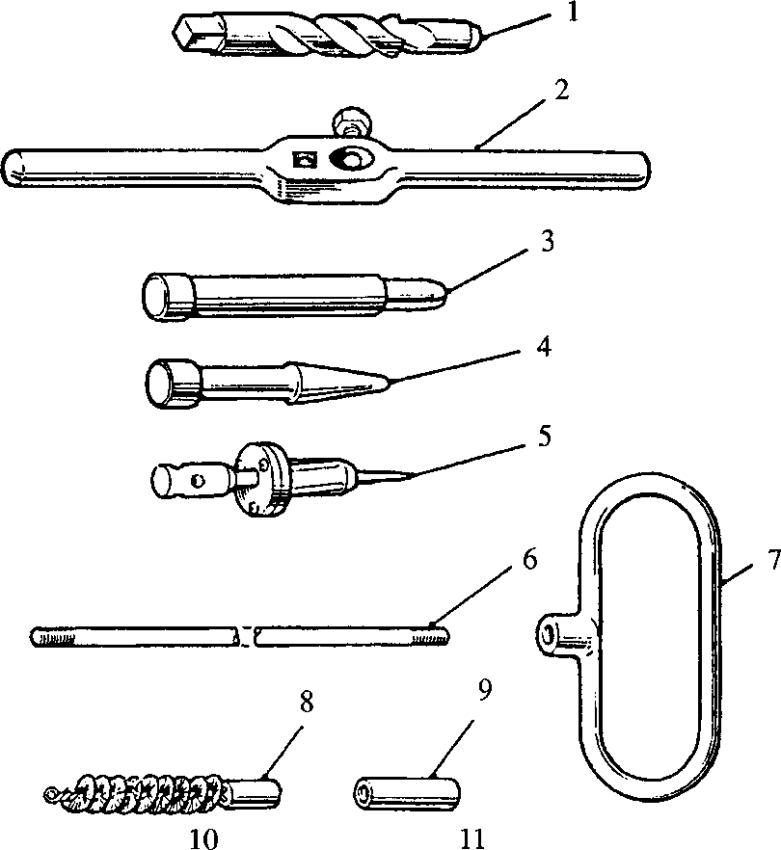

12

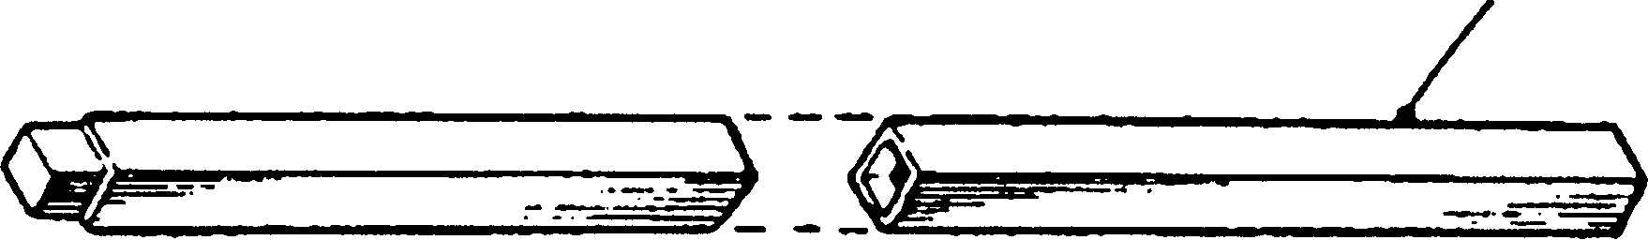

**13**

n. *T—J*'i- —

**SPD00351**

**Key To Numbers**

|  |  |  |  |
| --- | --- | --- | --- |
| 1. | Tube drill | 8. | Tube brush |
| 2. | Wrench | 9. | Connector |
| 3. | Centralising pin | 10. | Tube plug |
| 4. | Taper drift | 11. | Brush rod plug |
| 5. | Roller expander | 12. | Square extension |
| 6. | Extension rod | 13. | Tubular extension |
| 7. | Brush handle |  |  |

**Fig KF.2 Cooler cleaning and re-tubing tools**

CHAPTER 4

TESTING AND TUBE RENEWAL

1. Whenever possible it is recommended that major overhaul of the heat exchanger is carried out by Serck Heat Transfer. All repairs can be supported by a technical report on the condition of the heat exchanger, and advice given to prevent any recurrence of any avoidable troubles.
2. Where it is impractical for the heat exchanger to be returned to the manufacturer for repair, and no new tubestack is available, tubes may be renewed with the aid of the toolkit shown in Fig KF.2. It must be emphasised that tube renewal should only be carried out where full workshop facilities are available, together with a means of pressure testing.
3. Where such facilities are not available, the complete tubestack should be renewed.
4. As a temporary measure a defective tube(s) should be isolated by using the wooden plugs supplied with each tool kit. A plug should be driven securely into ends of the tube(s). New tubes or a new tubestack should be fitted as soon as possible.

Testing

1. With the heat exchanger assembled, apply pressure on both sides of the tubes independently and examine the tubes, plates and joints for leakage.
2. The test pressures are as follows:-

Coolant side (over tubes) 7.03 kg/cm2 (100 lb/in2)

Sea water side (through tubes) 7.03 kg/cm2 (100 lb/in2)

Tube Renewal

1. The baffle plates are a close fit to the outer diameter of the tubes in the stack. To avoid distortion and damage to the plates during tube removal, the tubestack should be descaled and all deposits removed before attempting to remove the tubes.
2. Remove tubestack from heat exchanger cylinder and mount the tubestack in a horizontal position. Mount so as to avoid damage to the tubes and baffle plate.
3. Fig KF.3/1 - Fit tube drill (l)(Fig KF.2) to wrench (2), fill drill flutes with grease to retain cuttings and drill out defective tube end in expansion end tube plate until free of solder bonding on inner face of tubeplate. Remove drill and clean away burrs from end of tube.
4. Fig KF.3/2 - Insert centralising pin (3)(Fig KF.2) through the tubeplate and locate the pilot portion of the pin in the tube bore.
5. Fig KF.3/3 - Using tube drill (l)(Fig KF.2) and wrench (2), drill out defective tube end in fixed tubeplate. Withdraw drill, remove burrs from end of tube and replace drill locating the pilot portion of the drill in the tube bore.
6. Fig KF.3/4 - Drive the centralising pin into the expansion end tubeplate until the head contacts plate, forcing the tube, guided by tube drill (l)(Fig KF.2), through the fixed end tubeplate. Keep a close watch on the gill plates when 'starting' the tube to ensure that distortion is not taking place due to tube plate adhesion.

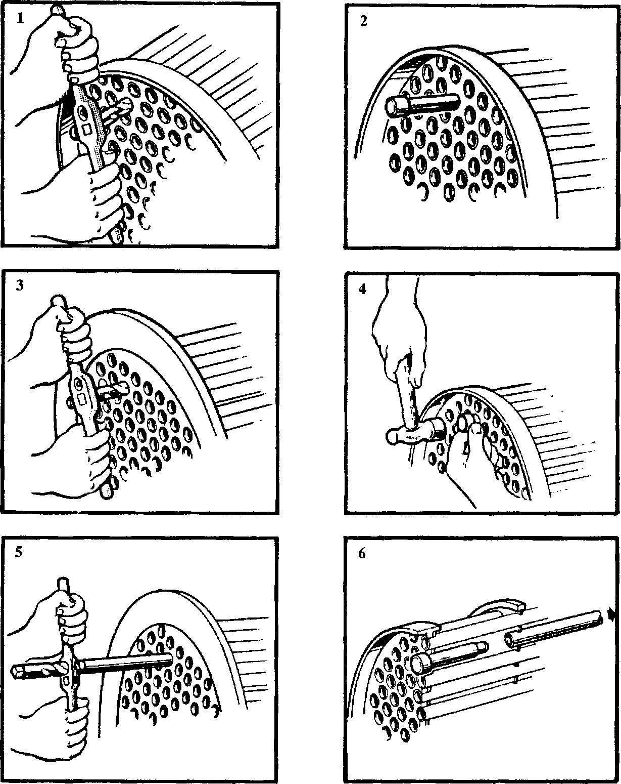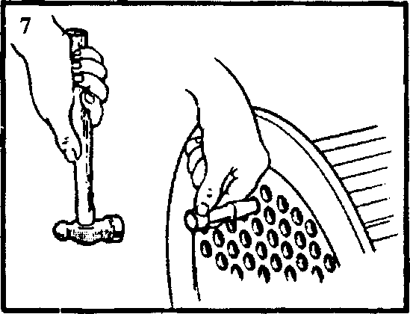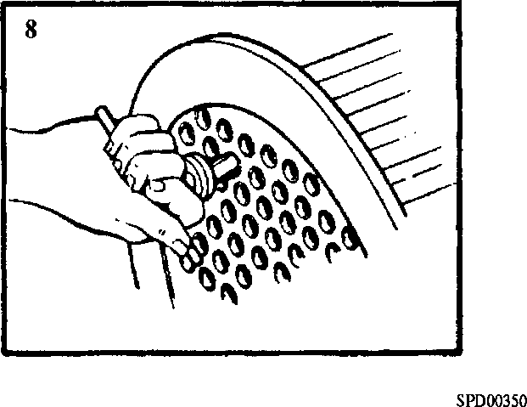

Fig KF.3 Method of re-tubing

1. Fig KF.3/5 - Place wrench (2)(Fig KF.2) over the tube end and lock the wrench and tube to the pilot portion of the drill with the wrench grubscrew.
2. Fig KF.3/6 - Carefully work the tube out of the stack by means of the wrench. Remove the centralising pin from the expansion end tubeplate.
3. Fig KF.3/7 - Carefully clean out the tubeplate holes. Do not overwork thereby enlargening the holes. Clean the ends of the new tube to allow for solder bonding after fitting. Insert the new tube, taking care not to damage the gill plates and secure in position by expanding with taper drift (4) at each end.
4. Fig KF.3/8 - Insert roller expander (5)(Fig KF.2) into the tube and rotate in a clockwise direction using light finger pressure. Allow the expander to feed itself into its full extent, do not force the feed. Repeat for the other end of the tube.
5. Mount the tubestack vertically and apply a small quantity of flux to the outer

diameter of the tube as close as possible to the inner face of the tubeplate. Working from the outer face of the tubeplate, heat the tube sufficiently to 'run' the solder on the tubeplate inner face to complete the seal between tube and tubeplate. Localise the heating as much as possible. Repeat for the other end of the tube.

CHAPTER 5

ASSEMBLY AND FITTING

Assembly (Fig KF.4)

NOTE All joints and 'O' rings must befitted dry unless otherwise stated.

1. Mount cylinder assembly (14) vertically.
2. Screw an eye bolt into the tapped hole in fixed end tubeplate (17) attach lifting tackle and lift tubestack (3).
3. Pass a new joint ring (2) over the tubestack and locate against the inner face of the fixed end tubeplate flange. If required the joint ring may be retained in position with petroleum jelly.
4. Lower the tubestack into the cylinder taking care to avoid damage to the stack and align the register marks on the fixed tubeplate and cylinder.
5. Remove lifting tackle and eyebolt and screw in and tighten tubeplate blanking plug
6. . Centre punch threads to lock plug in position.
7. Place a new joint ring (2) over the tubeplate spigot, fit the fixed end water box (18) over the four studs and fit and secure the nuts (19). Tighten nuts evenly to avoid distortion.
8. Invert the heat exchanger or lay in a horizontal position to allow access to the expansion end.
9. Place new joint ring (11), leakage ring (4) and second new joint ring (11) over the expansion end tubeplate, pass expansion end cover (10) over its retaining studs and secure with four nuts (8). Tighten nuts evenly to avoid distortion.
10. Fit adaptors (16), drain cocks, vent plugs (6), new protector rods (1) with plugs
11. , and drain plugs (9), all with new fibre washers (5) and (22) to required position.

Fitting

1. Using a suitable sling, lift heat exchanger into position and fit and tighten Ml6 securing setbolts.
2. Using new joints, connect coolant and sea water piping.
3. Fill engine cooling system. The system is self venting (see Section DA).
4. The sea water pump is driven from the engine crankshaft and it will therefore be necessary to run the engine to fill the sea water system. The air vent plug (6) on the heat exchanger end cover should be opened to help vent the unit. Refer also to the Shipbuilders Instructions for venting.

CHAPTER 6

ACID DESCALENTS FOR WATER CIRCUITS

|  |  |  |
| --- | --- | --- |
| TYPE OF DEGREASANT | BRAND | SUITABILITY FOR ALUMINIUM ALLOYS |
| LIQUID | H.T.L.3A (Houseman & Thompson Ltd) | Not recommended |
|  | Pensalt PM-90 (Pensalt Metal Processing) | Not recommended |
|  | Clensol 'P' and Clensol ’LP (Clensol Ltd) | Not recommended |
|  | Cleanix H.C. (Clensol Ltd) | Recommended |
|  | Armohib 28 inhibitor and Dilute  Hydrochloric Acid Sol (Armour Hess Chemicals Ltd) | Not recommended |
|  | Uninhibited Hydrochloric Acid (Dilute Solution) | Not recommended |
| SOLID | H.T.L. NO. 5 (Houseman & Thompson Ltd) | Not recommended |
|  | Cleanix Powder (Clensol Ltd) | Recommended |

The above products have been tested by Serck Heat Transfer and have been found to be suitable for descaling, whilst at the same time having no significant effect on the materials of construction, when used in accordance with the manufacturers instructions. No attempt has been made to compare the suitability, efficiency and cost of similar competitive products.

CHAPTER 7

SPECIAL TOOLS

The following special tools are sufficient for carrying out all general maintenance, dismantling, overhaul and assembly operations on the heat exchanger as detailed in this section.

NOTE These tools are only shown in the Illustrated Parts List if they have been ordered as part of the contract.

|  |  |  |
| --- | --- | --- |
| DESCRIPTION | PART NO | USE |
| Toolkit | OD28961 | For removal and fitting of tubes |

Key To Numbers (Fig KF.4)

1. Protector rod
2. Joint ring
3. Tubestack
4. Leakage ring
5. Washer for plug
6. Vent plug
7. Stud
8. Nut
9. Drain plug
10. Cover expansion end
11. Joint ring
12. Disc baffle plate
13. Ring baffle plate
14. Cylinder assembly
15. Mounting foot holes
16. Adaptor
17. Fixed end tubeplate
18. Fixed end water box
19. Nut
20. Blanking plug
21. Protector rod plug
22. Washer for plug

200KF029

in

1 2 3 4

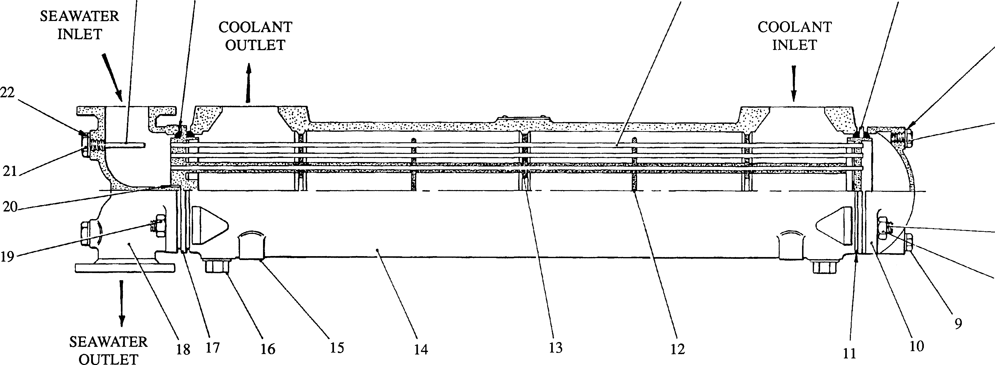

Fig KF.4 Heat exchanger